
American International University-Bangladesh (AIUB)
Faculty of Engineering
Department of CSE, EEE, and CoE
EEE4103 MICROPROCESSOR AND EMBEDDED SYSTEM

COURSECAPSTONEPROJECTPROPOSALFORM
SEMESTER: SUMMER 2024-25
PROJECT TITLE: (must be an embedded system designed using Arduino/STM32/Raspberry Pi with other necessary sensors, actuators, components, etc. Both hardware implementation and simulation must be shown by the end of the semester. However, the proposal form should be submitted within the next two weeks from now on) 2 MARKS
SURVEY: (to develop a process for complex engineering problems considering cultural and societal factors (use Google or Microsoft Forms to design questions, show the outcomes in the form of a pie/bar chart, show the links of questions, minimum 10 questions, and 40 respondents) 7 MARKS
AIMS AND OBJECTIVES OF THE PROJECT: (there must be a minimum of three aims and
objectives of your work using measurable action verbs of Bloom’s Taxonomy, for example, design, simulate, implement, analyze, etc.) 4 MARKS
LITERATURE REVIEW: (must be related to embedded system design with other necessary citations from the most recently published papers. At least 5 most recent publications must be collected, studied, identified the problems, and then discussed in this section) 5 MARKS
EXPERIMENTAL BLOCK DIAGRAM: (demonstrate how this project is inter-connected with various components and how various signals flow among them using text boxes and arrows) 5 MARKS
POSSIBLE OUTCOMES OF THE PROJECT: (describe how this project can help society and improve the culture of society) 4 MARKS
PROJECT TIMELINE (GANTT CHART): describe how this project will progress with time by breaking the whole task into several components concerning some specific time using a horizontal or a vertical bar graph) 5 MARKS
REFERENCES: (only published paper-based references are allowed with the IEEE format, don’t use YouTube links, Wikipedia, or any random websites for references, however, datasheets, databases, can be used as references with the appropriate formats, links, and access dates): 3 MARKS
Sample for the conference paper:
[1] M. H. Bhuyan and Q. D. M. Khosru, “Linear Asymmetric Pocket Profile Based Pinch Off Voltage Model for Nano Scale n-MOSFET,” Proceedings of the IEEE sponsored International Conference on Electrical, Computer and Communication Engineering (ICECCE2017), organized by the Chittagong University of Engineering and Technology (CUET), Cox’s Bazar, Bangladesh, 16-18 February 2017, pp. 28-32.
Sample for the journal paper:
[1] M. H. Bhuyan and Q. D. M. Khosru, “Effects of Temperature on Reverse Short Channel Effect in Pocket Implanted Sub-100 nm n-MOSFET,” Journal of Materials Science and Engineering, USA, 1934-8959, vol. 4, no, 7, July 2010, pp. 18-23, DOI:10.17265/2161-6213/2010.07.004.
Instructions:
- There is no definite format to write the proposal, but students must follow the mentioned instructions properly.
- Fill in the form accurately with all necessary information.
- Make a color print on this form.
- Figures, tables, charts, circuit diagrams, block diagrams, and wave shapes must be color printed.
- The survey form links with the answers must be provided in the proposal form.
NAME: Basudeb Kundu  ID : 23-50856-1  PROGRAM: CSE  EMAIL: 23-50856-1@student.aiubn.edu | NAME: Prohlad Chandra Das  ID: 23-50922-1  PROGRAM: CSE  EMAIL: 23-50922-1@student.aiub.edu
NAME: Debashis Kumar Das  ID: 23-50953-1  PROGRAM: CSE  EMAIL: 23-50953-1@student.aiub.edu | NAME: Indronil Dutta Nill  ID: 23-50974-1  PROGRAM: CSE  EMAIL: 23-50974-1@student.aiub.edu
NAME: Nafiur Rahman Nirob  ID : 23-50991-1  PROGRAM: CSE  EMAIL: 23-50991-1@student.aiub.edu | NAME:  ID:  PROGRAM:  EMAIL:
REMARKS (for OFFICE use only)

FOR FACULTY USE ONLY
COMMENTS BY COURSE TEACHER:
COURSE TEACHER’S NAME COURSE TEACHER’S SIGNATURE DATE

GROUP MEMBERS
(Maximum 6 students are permitted to carry out a single Project. However, depending on the capability of the students, 4 students may be allowed but not less than that)
Course Name: |  | Microprocessor and Embedded System | Course Code: | EEE 4103
Semester: |  | Summer 2024-2025 | Sec: K
Faculty Member: |  | Md. Ali Noor
Capstone Project  Title: |  | Design and Implementation of an Obstacle Avoiding Car Using Arduino Uno R3
Project Group No. |  | 04
Sl # | Student ID # | Student Name | Obtained Marks
1. | 23-50856-1 | Basudeb Kundu
2. | 23-50922-1 | Pohlad Chandra Das
3. | 23-50953-1 | Debashish Kumar Das
4. | 23-50974-1 | Indronill Dutta Nill
5. | 23-50991-1 | Nafiur Rahman Nirob
KPIs | Excellent [6-7] | Proficient [4-5] | Good  [3] | Acceptable [2] | Unacceptable [1] | No  Response [0] | Se  cured Marks
Survey | The survey developed as a process for complex engineering problems  considering cultural and societal factors have superior variables,  targets, measures, and the implementation  process is clear and  challenging for future  project implementation with several possible  outcomes having good impacts. | The survey developed as a process for  complex engineering  problems considering  cultural and societal factors has good  variables, targets, measures, and  The implementation process is clear and  challenging for future  project implementation, with some possible outcomes and little impact. | The survey developed as a process for  complex engineering  problems considering cultural and societal  factors has moderate  variables, targets, measures, and  The implementation process is clear and  challenging for future  project implementation, with a few possible outcomes and impacts. | The survey developed as a process for  complex engineering  problems considering  cultural and societal factors has good  variables, targets, measures, and The implementation process is somewhat  clear for future project  implementation, with very few possible  outcomes and little impact. | The survey developed as a process for  complex engineering  problems considering  cultural and societal factors has poor  variables, targets, measures, and  the implementation  process is very unclear for future project  implementation with a  few possible outcomes but no impacts. | No  Response at all/  copied from  others  /identical submissio  ns with gross  errors/  image file printed
KPIs | Excellent [2] | Proficient [1.5] | Good  [1] | Acceptable [0.5] | Unacceptable [0] | No Response  [0] | Secured Marks
Project Title | The title reflects an issue related to complex  engineering problems showing targets and  methods with possible outcomes. | The title reflects an issue related to  complex engineering problems showing  targets and methods but some missing issues. | The title reflects an issue related to the  course capstone project but there may be some missing issues. | The title reflects an issue related to the course capstone  project but is not complete or specific. | The title does not reflect any issues related to the  course capstone project. | No Response at all/ copied from others /identical  submissions with gross errors/ image file printed
Comments |  |  |  |  |  | Total Marks (2)
Assessment Materials and Marks Allocation:
COs | Assessment Materials | POIs | Marks
CO3 | Course Capstone Proposal Form | P.c.2.C6 | 35
Assessment Rubrics:
KPIs | Excellent [5] | Proficient [4] | Good  [3] | Acceptable [2] | Unacceptable [1] | No Response  [0] | Secured Marks
Experimen tal Block  Diagram | The block diagram is drawn to show the  connections of all the  possible components or sub-systems to show  their interdependence  with all possible flows of signals from inputs to outputs. | The block diagram is drawn to show the  connections of all of the possible components or sub-systems to show  their interdependence with a few missing  flows of signals from inputs to outputs. | The block diagram is drawn to show the  connections of most of  the possible components or sub-systems to show their interdependence  with a few missing flows of signals from inputs to outputs. | The block diagram is drawn to show the  connections of a few  possible components  or sub-systems to show their  interdependence with  some missing flow of  signals from inputs to outputs. | The block diagram is not drawn to show  the connections of all  possible components  or sub-systems to show their  interdependence and flow of signals from inputs to outputs. | No Response at all/ copied from others  /identical submissions with gross  errors/ image file printed
Comments |  |  |  |  |  | Total Marks  (5)
KPIs | Excellent [4] | Proficient [3] | Good  [2] | Acceptable [1] | Unacceptable [0.5] | No Response  [0] | Secured Marks
Possible  Outcomes | Outcomes are written to achieve complex  engineering problems’ solutions considering cultural and societal factors and showing  measurement, and  implementation  processes to attain the outcomes with all possible impacts. | Outcomes are written to achieve complex  engineering problems’ solutions considering cultural and societal factors and showing  measurement, and  implementation  processes to attain the outcomes with some impacts. | Outcomes are written to achieve complex  engineering problems’ solutions considering cultural and societal factors and do not  show measurement, and implementation  processes to attain the outcomes without showing any impacts. | Outcomes are written to achieve complex  engineering problems’ solutions but do not  consider cultural and  societal factors and do  not show measurement, and implementation  processes to attain the outcomes without showing any impacts. | Outcomes are not written to achieve complex  engineering problems’  solutions do not consider cultural and societal  factors and do not show measurement, and  implementation  processes to attain the outcomes without showing any impacts. | No Response at all/ copied from others  /identical submissions with gross  errors/ image file printed
Comments |  |  |  |  |  | Total Marks (7)
KPIs | Excellent [4] | Proficient [3] | Good  [2] | Acceptable [1] | Unacceptable [0.5] | No  Response [0] | Secured Marks
Aims and  Objectives | Aims and objectives are written to solve complex engineering problems  considering cultural and societal factors with specific targets,  measurement, and  implementation  processes that are clear and challenging and  have several possible  outcomes having very good impacts. | Aims and objectives are written to solve  complex engineering  problems considering cultural and societal factors with general  targets, measurement, and implementation  processes that are not clear and challenging  and have some possible outcomes having good impacts. | Aims and objectives are written to solve  complex engineering  problems considering a few cultural and  societal factors with narrow targets;  measurement, and  implementation  processes are clear and challenging and have a few possible outcomes having some impacts. | Aims and objectives are written to solve  complex engineering  problems considering cultural or societal factors with a very  target; measurement and implementation  processes are not clear or challenging and  have little possible  outcome having no impact. | Aims and objectives are written to solve  complex engineering problems but do not  consider cultural and  societal factors with any targets;  measurement, and  implementation  processes are not clear  and challenging, and no possible outcomes have no impacts. | No  Response at all/  copied from  others  /identical submissio  ns with gross  errors/  image file printed
Comments |  |  |  |  |  | Total Marks (4)

KPIs | Excellent [5] | Proficient [4] | Good  [3] | Acceptable [2] | Unacceptable [1] | No Response  [0] | Secured Marks
Literature Review | Specific formats are maintained to review and cite  the literature with recent  publications.  Identified and analyzed the problem correctly. | Specific formats are maintained to review and cite the literature with recent  publications. Identified and analyzed the  problem correctly, but all issues were not  addressed with relevant or intended work. | Specific formats are maintained to review and cite the literature with recent and past  publications. Identified and analyzed the  problem correctly, but all issues were not  addressed with relevant or intended work. | Specific formats are maintained to review and  cite the literature with recent and past  publications. Identified  but could not analyze all the problems correctly, and all issues were not  addressed with relevant or intended work. | No specific formats are maintained to review and cite the literature with  recent publications. Could not identify and analyze  all the problems correctly, and all issues are not  addressed with relevant or intended work at all. | No Response at all/ copied  from others/ identical  submissions with gross  errors/ image file printed
Comments |  |  |  |  |  | Total Marks  (5)

Comments |  |  |  |  |  |  |  |  |  |  |  |  | Total Marks  (4)
KPIs | Excellent [5] |  | Proficient [4] |  | Good  [3] |  | Acceptable [2] |  | Unacceptable [1] |  | No Response  [0] |  |  | Secured Marks
Gantt Chart | Specific formats are maintained to draw the Gantt chart and  there is the order of workflow with all work to be done. |  | Specific formats are maintained to draw the Gantt chart and  there is the order of workflow with a few works missing. |  | Specific formats are maintained to draw the Gantt chart and  there is the order of  workflow with some works missing. |  | No specific formats are maintained to  draw the Gantt chart  and there is little order of workflow with some works missing. |  | No specific formats are maintained to draw the  Gantt chart and there is no order of workflow  with the most important works missing. |  | No Response at all/ copied from others/  identical submissions with gross errors/ image file printed
Comments |  |  |  |  |  |  |  |  |  |  | Total Marks (5)
KPIs |  | Excellent [3] |  | Proficient [2.5] |  | Good  [2] |  | Acceptable [1] |  | Unacceptable [0.5] |  | No Response  [0] |  | Secured Marks
References |  | Specific formats are maintained to write  references, and all are recently published  journal and conference papers having no missing information. |  | Specific formats are maintained to write the references, and all are  journal and conference papers, but some old papers have missing information. |  | No specific formats are maintained to write the references, and many are internet sources  with several missing  information and very old references. |  | No specific formats are maintained to  write the references and most of them  are internet sources with missing information. |  | No specific formats are maintained to  write the references,  and all are internet sources with missing information. |  | No Response at all/ copied from others /identical  submissions with gross errors/  image file printed
Comments |  |  |  |  |  |  |  |  |  |  |  | Total Marks (3)

SEMESTER: Summer 2024-2025
PROJECT TITLE: Design and Implementation of an Obstacle Avoiding Car Using Arduino Uno R3.
SURVEY:
Google form link: https://docs.google.com/forms/d/e/1FAIpQLScwydTvKLyGvILfuHNjR828H7Z3M6d9TzUwK84cGO1oJQfPw/viewform?usp=header
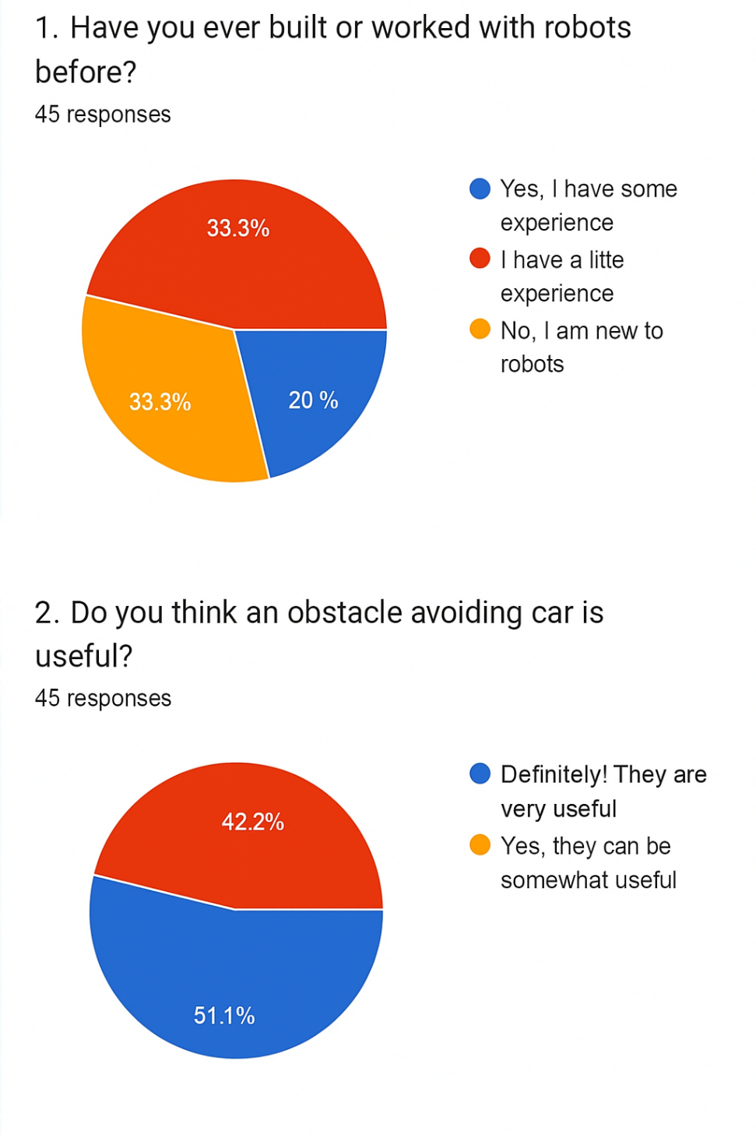
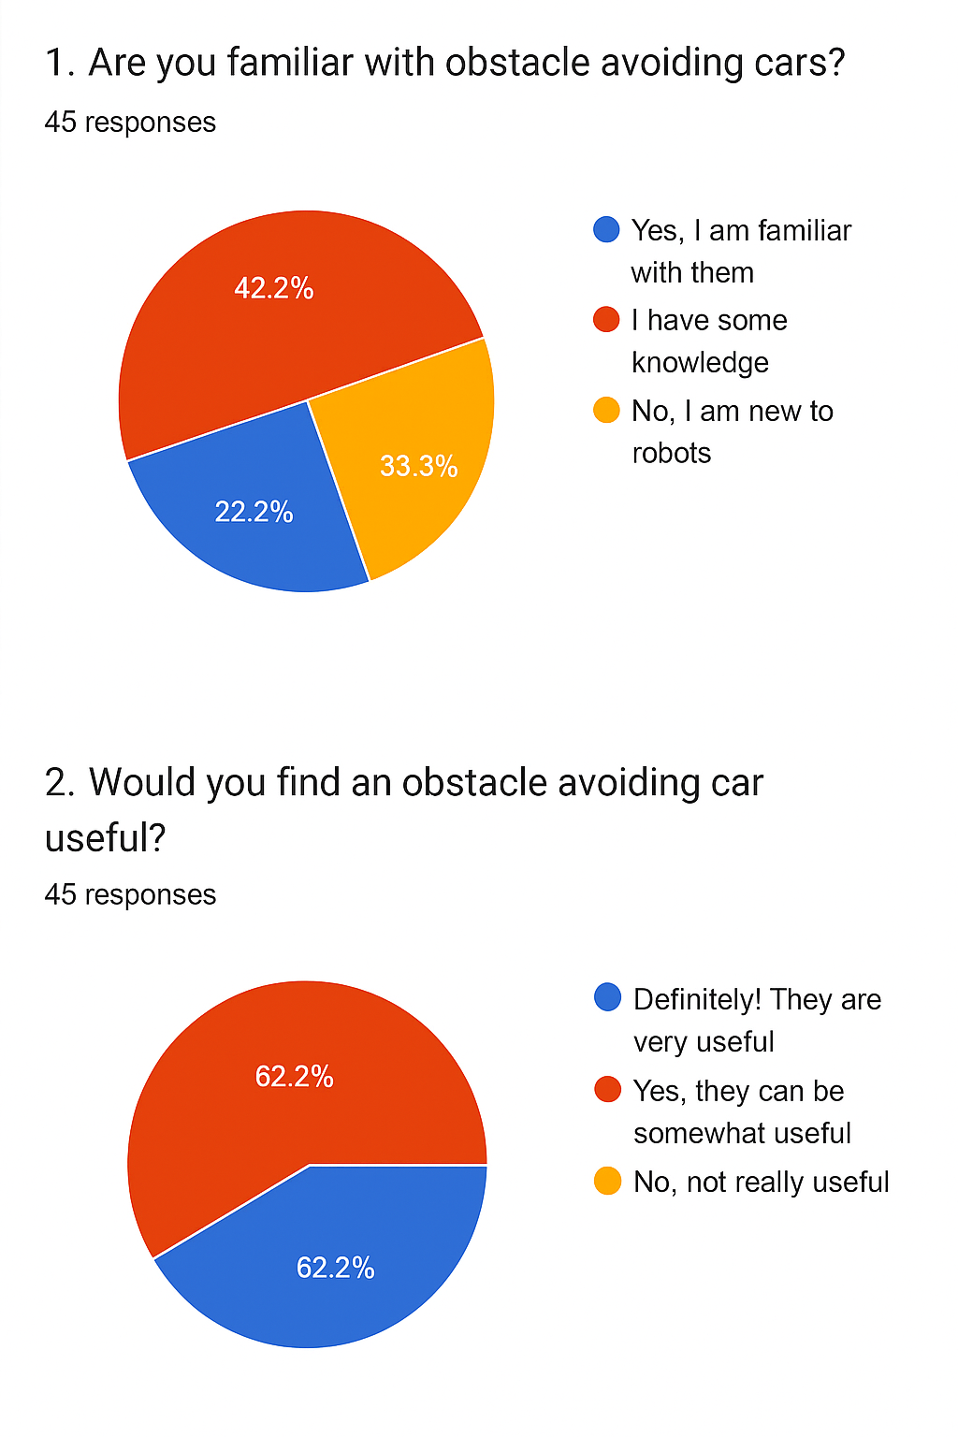
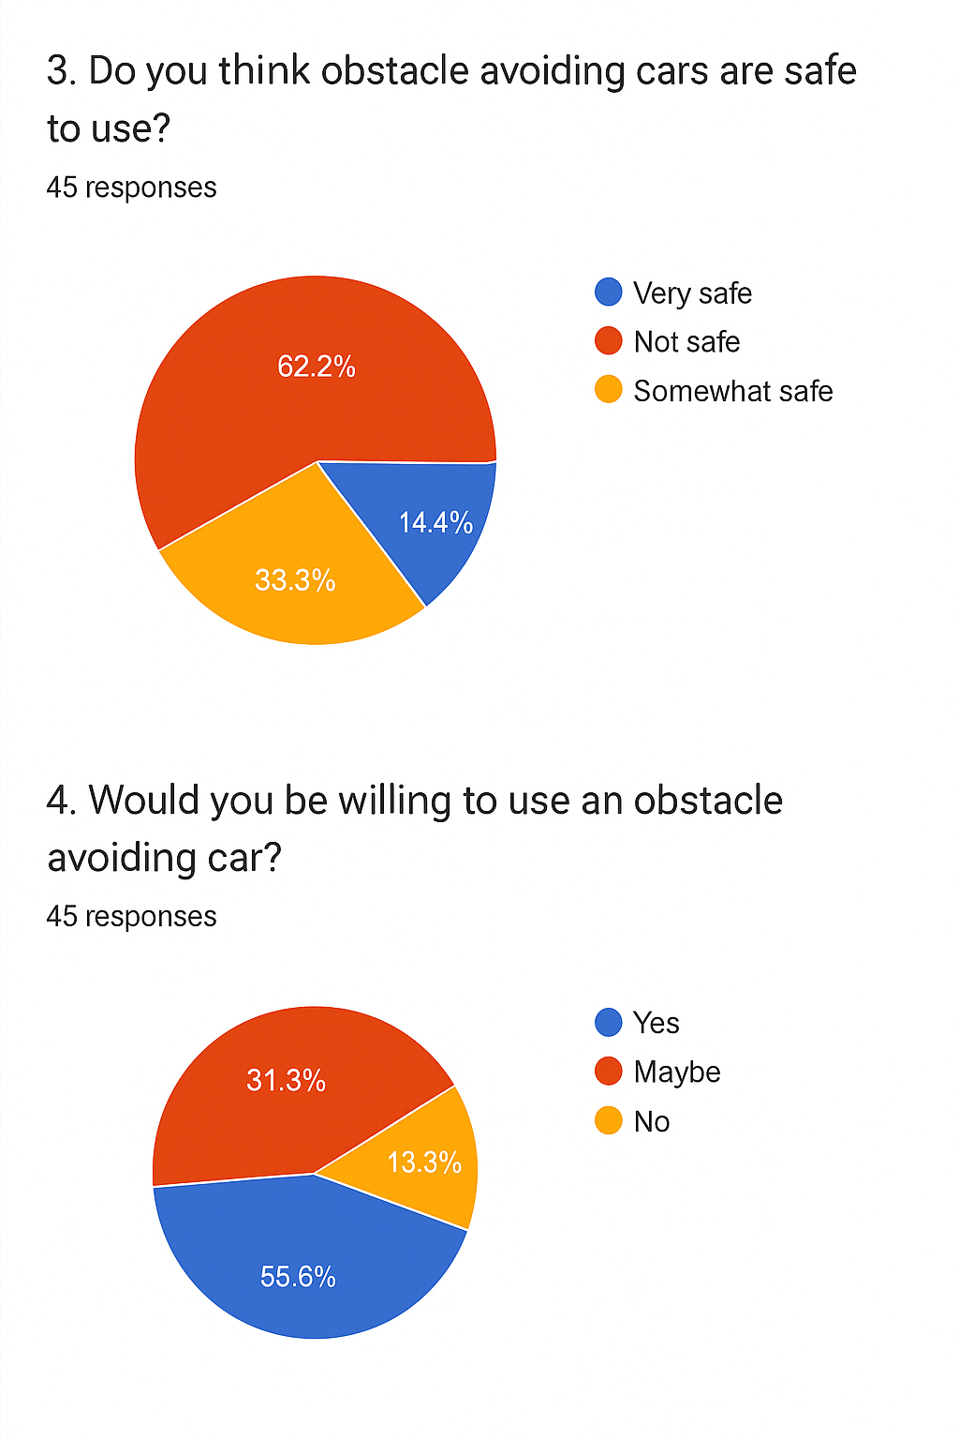

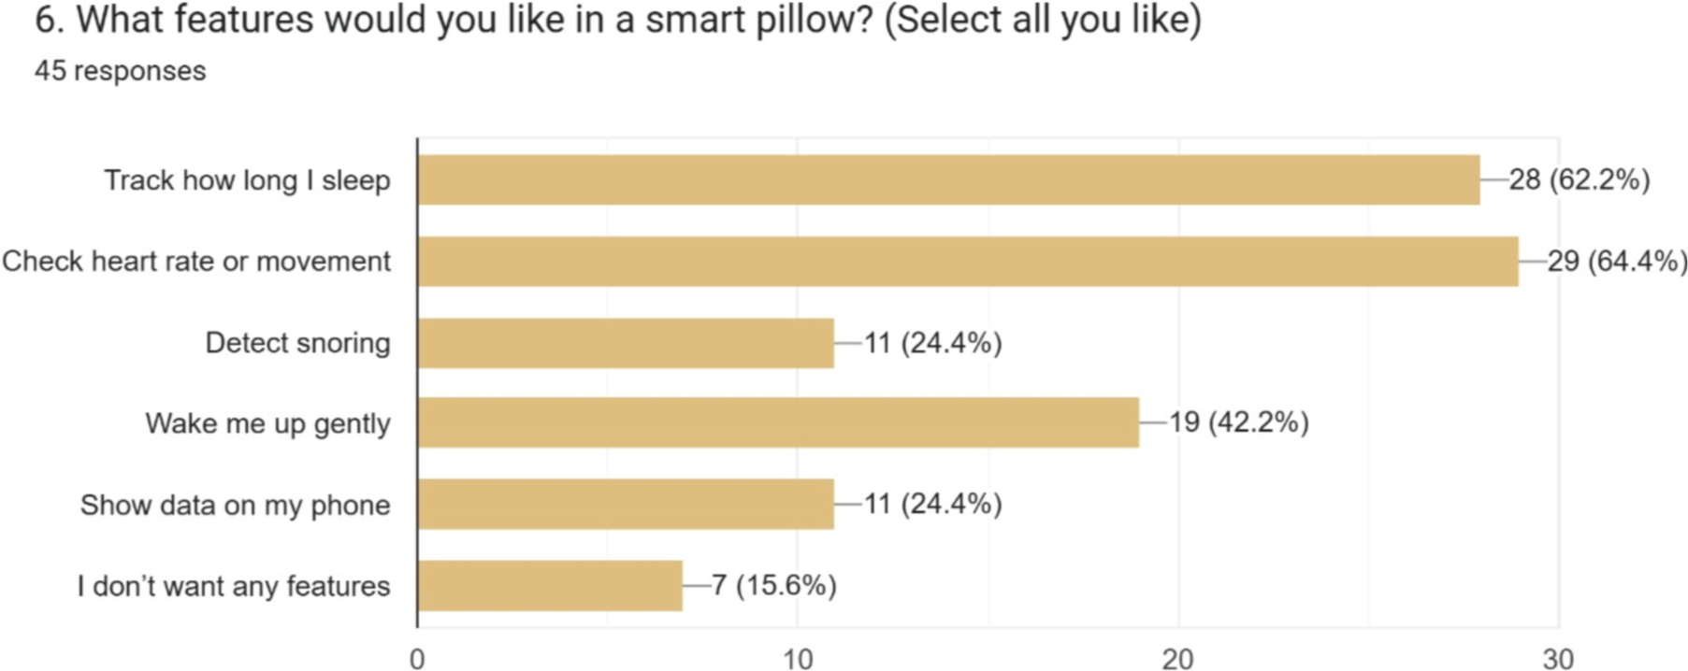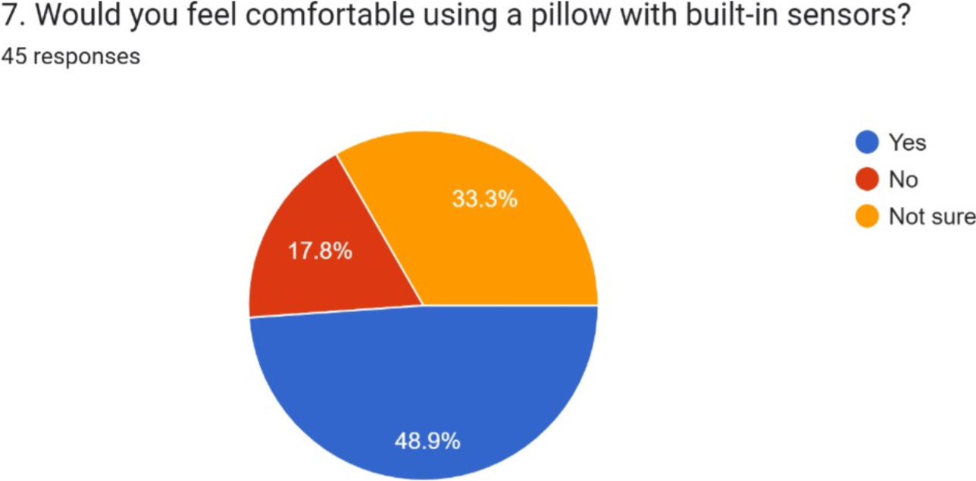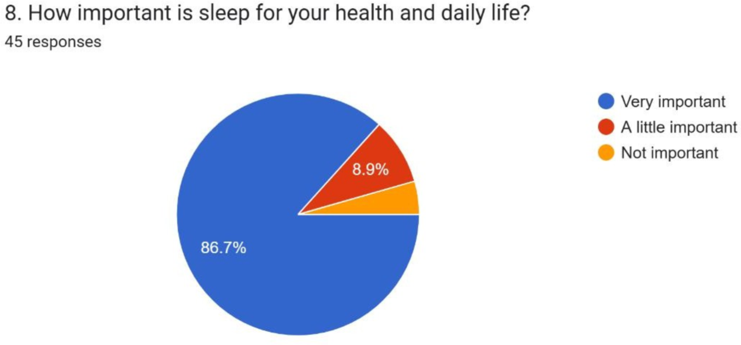

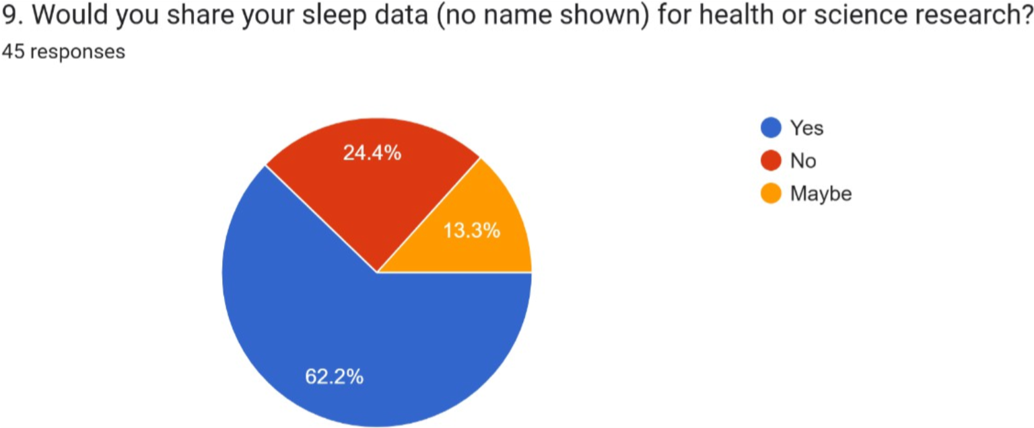
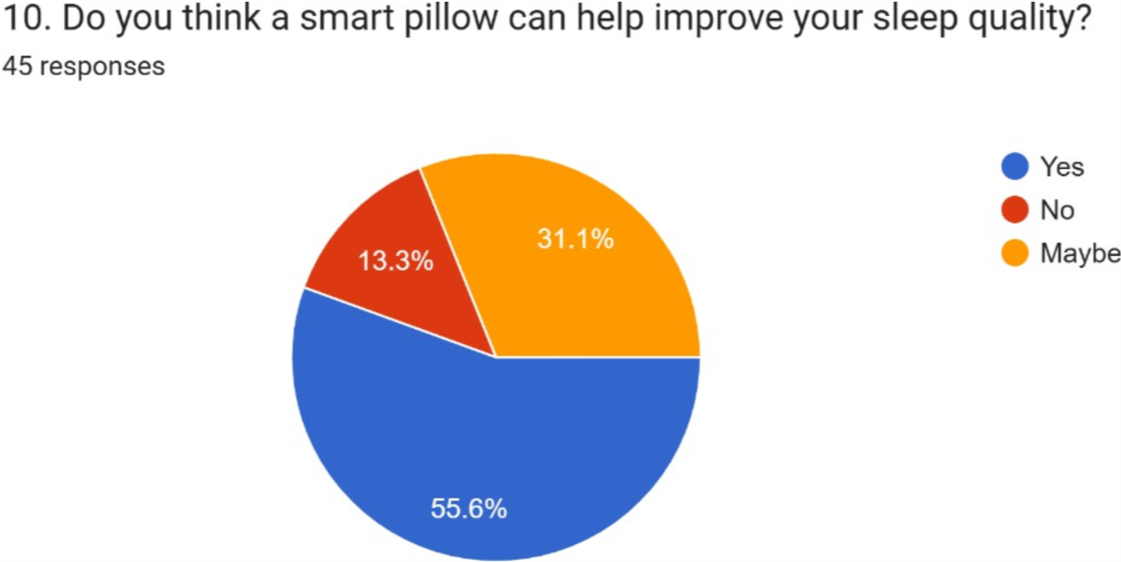
AIMS AND OBJECTIVES OF THE PROJECT:
Aims:
The aim of this project is to design and build an intelligent obstacle avoiding car using Arduino Uno R3 and various sensors. The car will be able to detect and avoid obstacles in its path automatically, ensuring smooth navigation without human control. The system should be simple, low-cost, and effective for use in robotics learning, automation, and smart vehicle applications.

Objectives:
- To design and implement an obstacle avoiding car using Arduino Uno R3 as the main controller.
- To integrate sensors such as:
  - Ultrasonic Sensor (HC-SR04) to detect obstacles and measure distance.
  - IR Sensor (optional) for close-range obstacle detection.
  - Motor Driver Module (L298N) to control the DC motors.
- To develop an algorithm that allows the car to automatically stop or change direction when an obstacle is detected.
- To build a motor-driven car chassis with wheels and connect it to the Arduino system.
- To ensure smooth and accurate movement of the car by controlling the speed and direction of motors.
- To minimize power consumption while maintaining reliable operation for longer run-time.
- To test the system in different environments and verify its ability to avoid obstacles effectively.
- To explore future improvements, such as adding Bluetooth/Wi-Fi modules for remote control, or sensors for mapping and autonomous navigation.

LITERATURE REVIEW:

[1] Arduino-Based Obstacle Avoidance Robot
S. Kumar, International Journal of Robotics and Automation, 2023
This paper presents a simple obstacle avoiding robot using Arduino Uno and ultrasonic sensors. The main challenge identified was the limited detection range, which sometimes caused collisions when obstacles were too close [1].
Problem Identified: Short sensing range and delayed obstacle response.
[2] Design of an Autonomous Car Using Arduino Uno
R. Ahmed et al., Proceedings of the 2023 IEEE International Conference on Intelligent Systems
This study developed an Arduino-controlled vehicle equipped with ultrasonic sensors and a motor driver. While the system successfully avoided obstacles, issues arose with motor synchronization, leading to jerky movements [2].
Problem Identified: Motor synchronization and unstable navigation.
[3] Obstacle Detection Robot Using Infrared and Ultrasonic Sensors
M. Singh et al., International Journal of Engineering Research, 2024
The authors proposed a dual-sensor approach combining IR and ultrasonic modules. Although accuracy improved, IR sensors often failed in varying light conditions, reducing reliability [3].
Problem Identified: IR sensor sensitivity to environmental light conditions.
[4] Low-Cost Robotics System for Obstacle Avoidance
A. Rahman et al., Journal of Embedded Systems and Applications, 2024
This research emphasized affordability, using Arduino Uno and HC-SR04 sensors for a student-level obstacle avoiding car. However, power consumption increased when multiple sensors operated simultaneously [4].
Problem Identified: Higher power usage with multiple active sensors.
[5] Intelligent Obstacle Avoidance Vehicle Using Arduino and IoT
N. Patel et al., IEEE International Conference on Smart Robotics, 2025
This paper explored IoT-enabled obstacle avoidance cars. The system transmitted data wirelessly for monitoring, but real-time processing was affected by communication delays [5].
Problem Identified: Data transmission delays affecting real-time navigation.

EXPERIMENTAL BLOCK DIAGRAM:
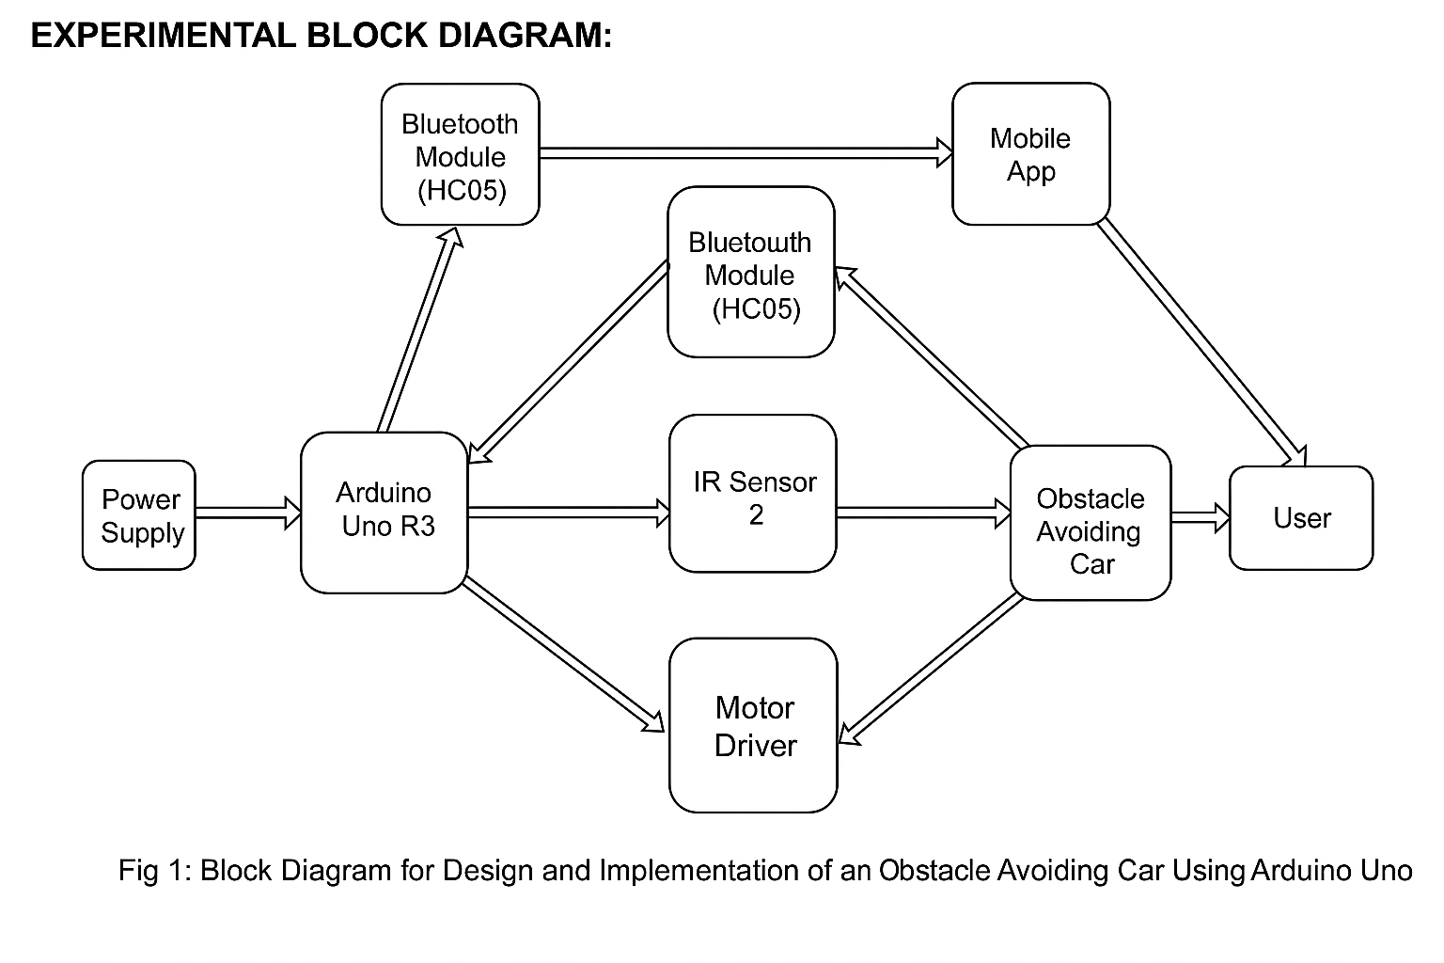
POSSIBLE OUTCOMES OF THE PROJECT:
1. An obstacle avoiding car that can detect and avoid obstacles automatically using sensors and Arduino Uno R3.
2. Real-time movement control of the car with smooth navigation in different environments.
3. Improved understanding of autonomous vehicle navigation and sensor-based decision-making.
3. Reliable detection of obstacles at varying distances and directions, minimizing collisions.
4. A car design that integrates sensors, motor driver, and Arduino without disturbing the car’s movement.
5. A system that consumes low power while ensuring efficient and accurate obstacle detection.
6. Possibility to upgrade the system in the future to include wireless control via Bluetooth, GPS navigation, or AI-based path planning.
7. A useful prototype that can lead to the development of more advanced robotics and autonomous vehicle systems.

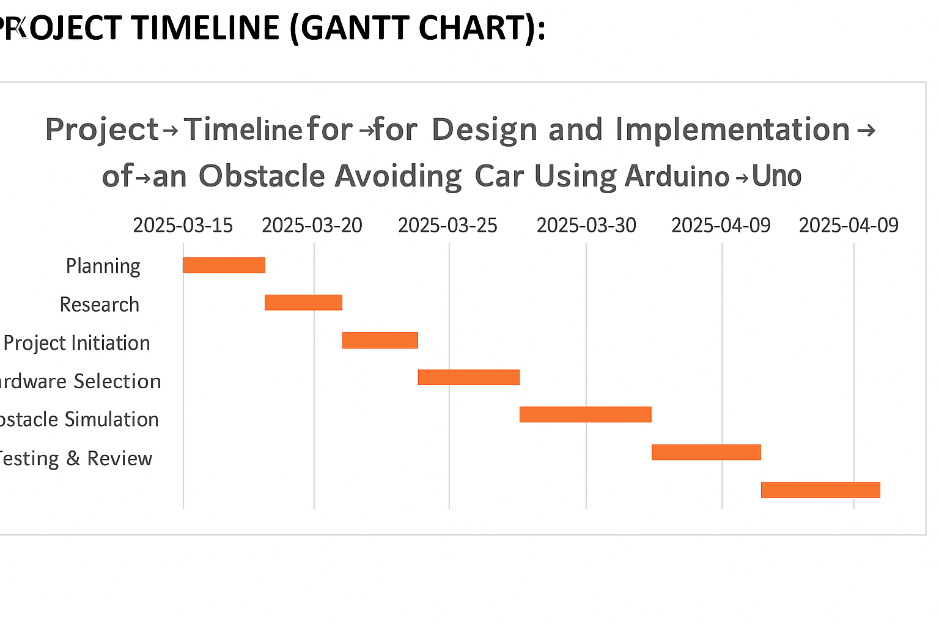
REFERENCES:
- K. S. P., “Health Monitoring with Smart Pillows,” Grenze International Journal of Engineering and Technology, 2395-5287, vol. 11, no. 2, 2024, pp. 203–210.
- J. A. Kausar, S. A. Sultana, M. Ahmed, and R. Hossain, “IoT-Based Smart Sleep Monitoring Using Arduino,” Proceedings of the 5th International Conference on Computing and Information Technology (ICCIT 2023), IEEE sponsored, Dhaka, Bangladesh, 15–17 May 2023, pp. 120–125.
- R. Patel, A. Mehta, and T. Joshi, “Arduino-Based Health Monitoring System for Sleep Apnea Detection,” Proceedings of the International Conference on Innovations in Engineering and Technology (ICIET 2023), Springer, Pune, India, 22–24 June 2023, pp. 88–94.
- M. S. Al-Mousa, T. Al-Dulaimy, and A. Qamar, “Embedded System Design for Sleep Behavior Analysis,” International Journal of Advanced Computer Science and Applications (IJACSA), 2158-107X, vol. 15, no. 3, March 2024, pp. 55–62, DOI:
10.14569/IJACSA.2024.015037.
- A. Thomas, J. Malik, and S. Prasad, “Smart Bed Monitoring System Using Sensors and Embedded Design,” Proceedings of the
IEEE Global Conference on Health Informatics (GCHI 2025), IEEE sponsored, Kuala Lumpur, Malaysia, 11–13 March 2025, pp. 34–39.

